## SEND TO OUTSIDE LAB

|  |  |
| --- | --- |
| User Name: ……………………………………………. | Trainer Name: Ruchira Ariyasinghe |
| User Sign. : ……………………………………………. | Trainer Sign. : ……………………………………………. |

**SEND TO OUTSIDE LAB**

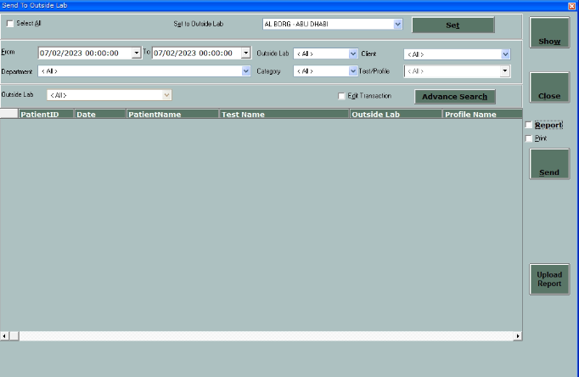

* This window is use for sample which are sent outside
* Click on Show button to **load** the outside test
* User can change the outside referral lab by using **Set** buton
* Click on **Send** button to update the send outside status.
* Click on  “Report” to get pint the report.